**OBJECT ORIENTED PROGRAMMING FINAL PROJECT REPORT**

**Ordering System**



**By:**

**Raja Farel Lecture:**

**Jude Joseph Lamug Martinez, MCS**

**School of Computing and Creative Arts BINUS International University**

**2023**

**Table of Contents**

1. Introduction 3
2. Class diagram 4
3. Implementation 5
4. Evidence of working program
5. Introduction

For Object Oriented Programming final project, I decided to create a food ordering system in java. For this project, the libraries that I use are java swing to create the graphical user interface (GUI) for my project. The program is very simple to use where users first need to enter their name and table number in the login page, after making that, users can press continue and the program will open the main page. On the main page, users can start ordering food by increasing the item’s quantity and then ticking the order checkbox, once the users does this, the food that there order will be recorded in the receipt and the receipt will be shown on the right side on the app. Users can add as many food as they want and once they finish ordering, they can press the total button on the bottom side of the app and it total amount and price of the food will be calculated. there are also a reset button that can delete the receipt if user would like to change their order and a receipt button that can save and print the receipt in a pdf file. Finally there are exit button which users can press once they finished using the program.

1. Class diagram

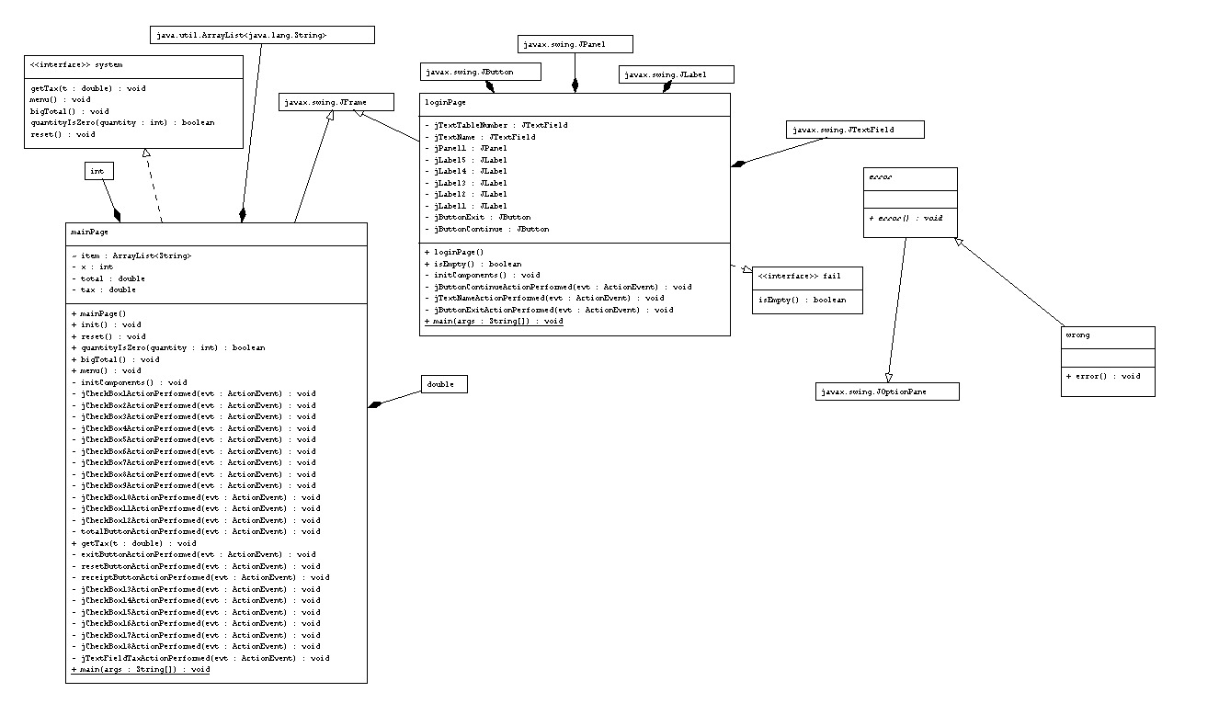

1. Implementation

In my project, there are two main classes which are the login page and main page. Here, I am going to explain essential code for each class

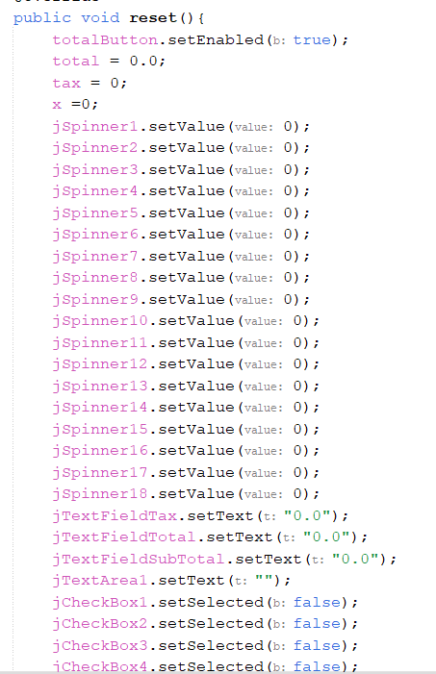

This method is used for the reset button, it deletes the existing receipt allowing the user to order again if they wished to change any of their order

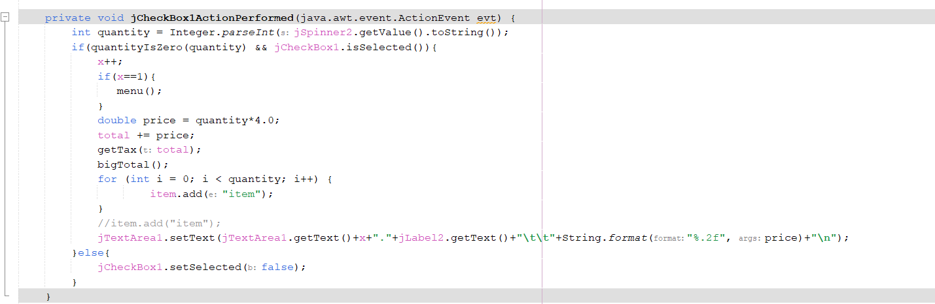

This method is for printing the selected item on the receipt

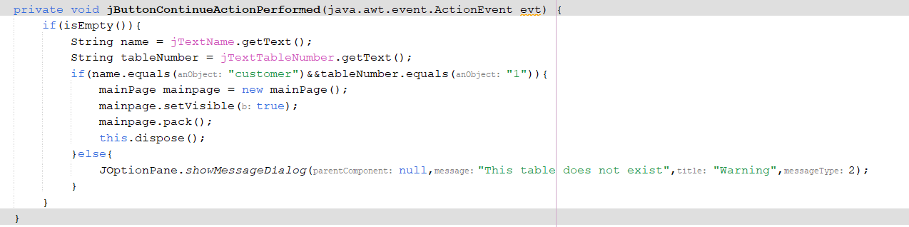

This method is used to return error message if the name and table number entered on the main page is not “customer” and “1”.

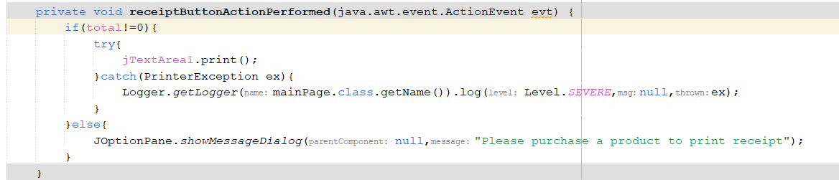

This method is used for printing the receipt in a pdf file.

1. Evidence of working program

Login Page

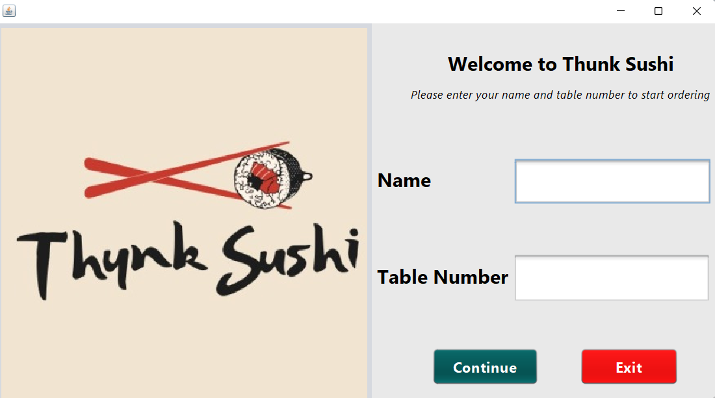

Warning if there are no username entered

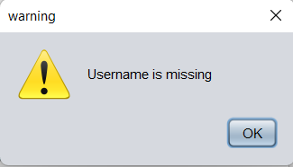

Warning if there are no table number entered

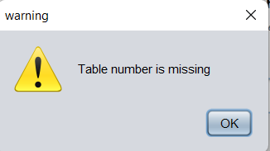

Main Page

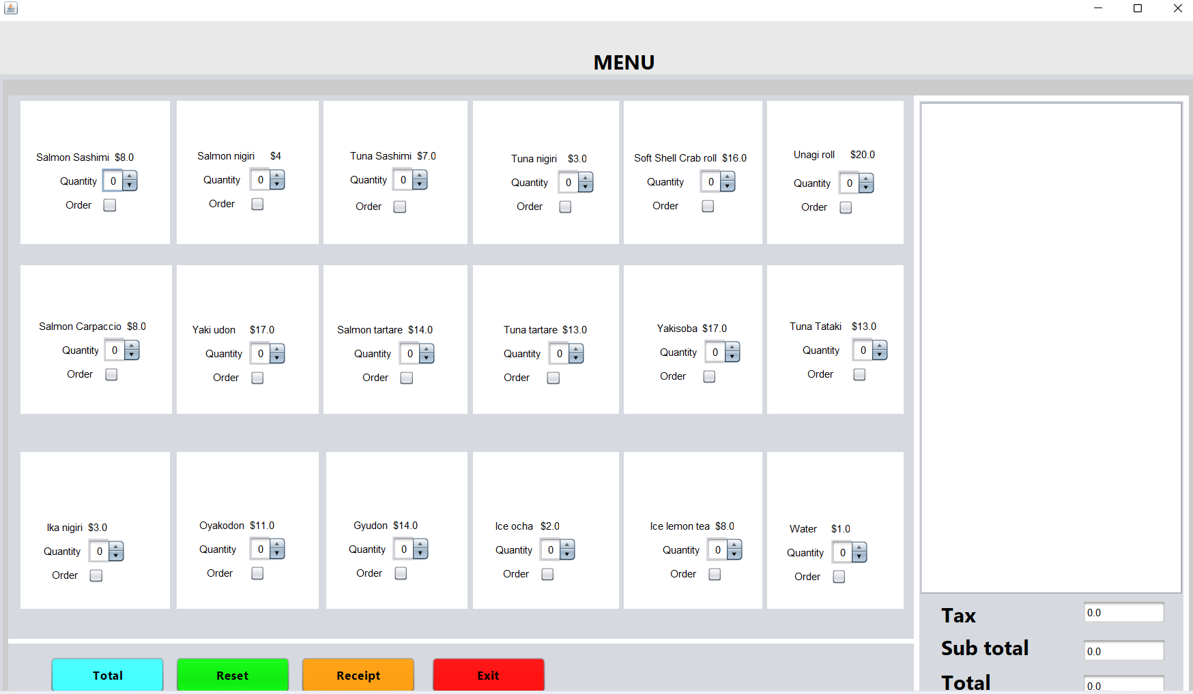

Warning if user tick the order checkbox when the quantity is zero

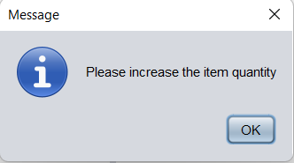

Warning if user does not have anything in the receipt when they press receipt button

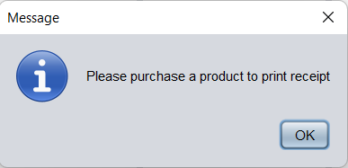

Main Page when ordering food

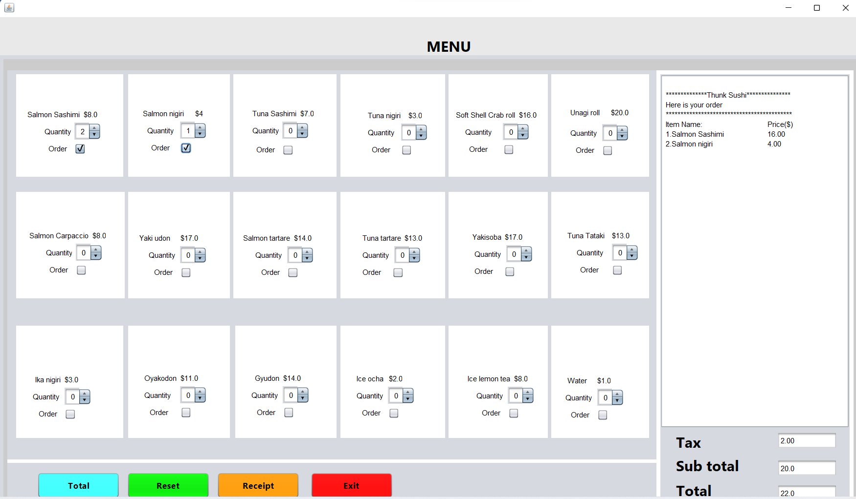

Main Page when user press the total button

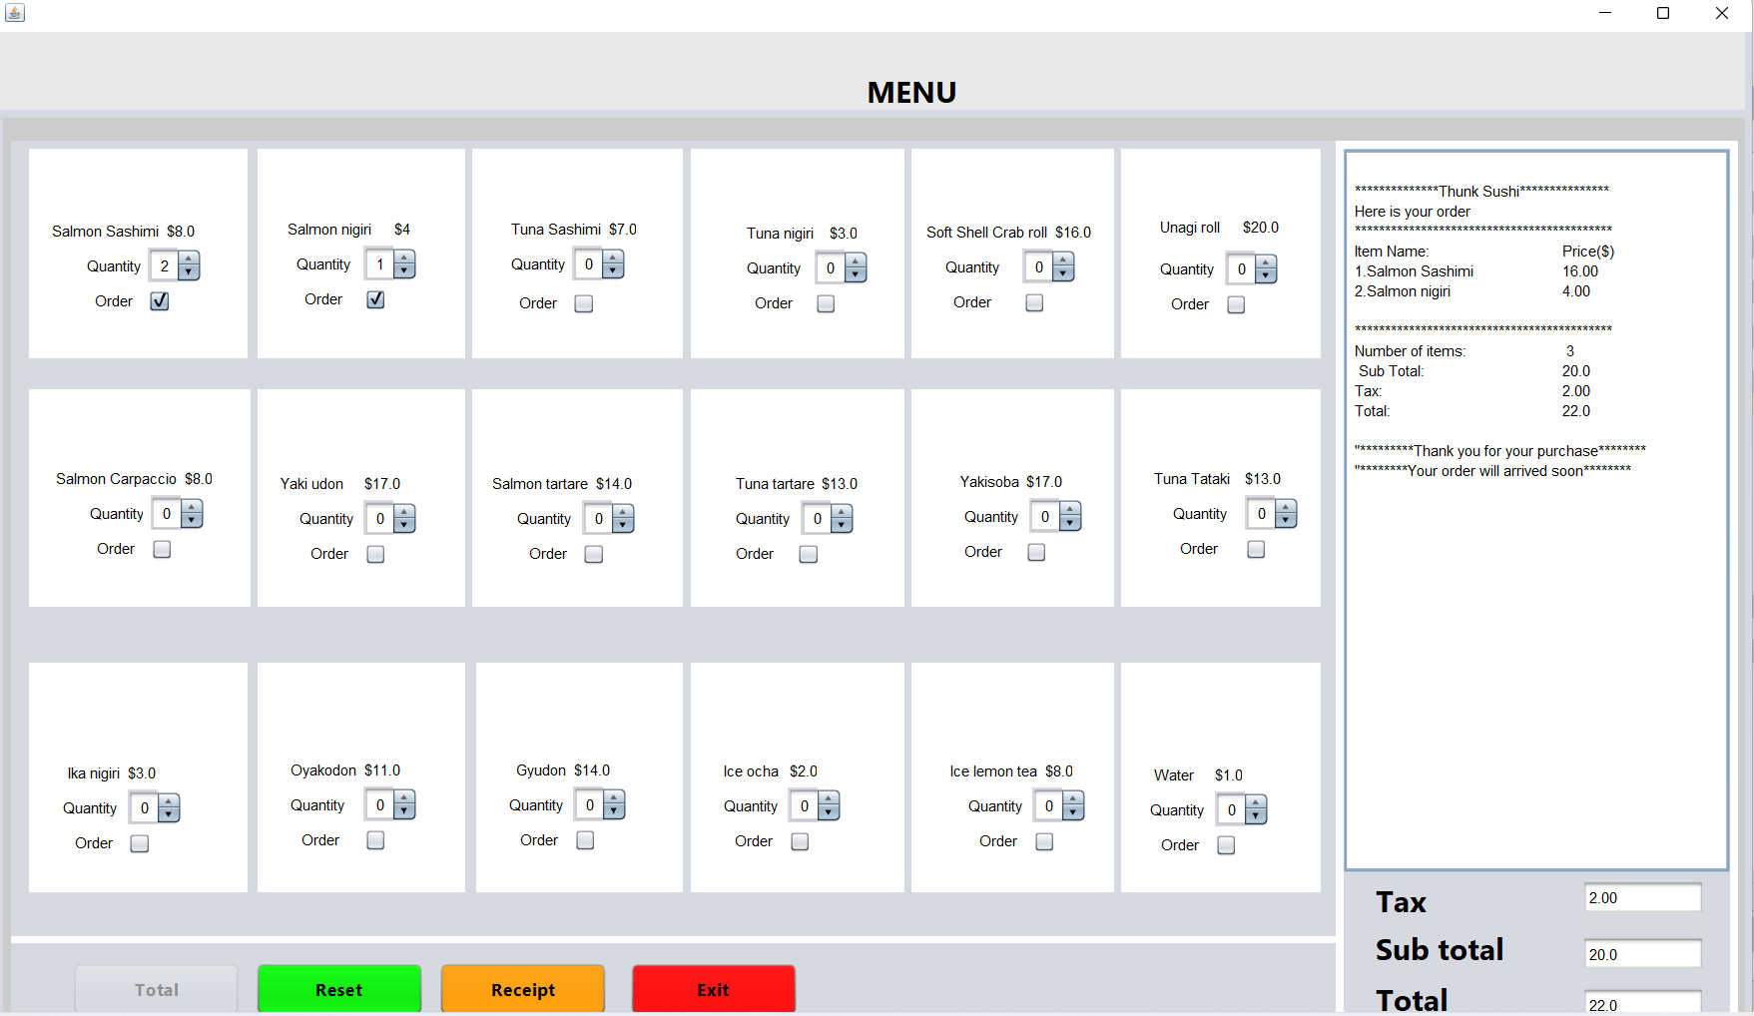

Receipt that are saved in a pdf file.

